**Step 1 : Various Ideas :**



**Step 2: Selecting some features and grouping them :**



**Step 3: Priority Chart :**

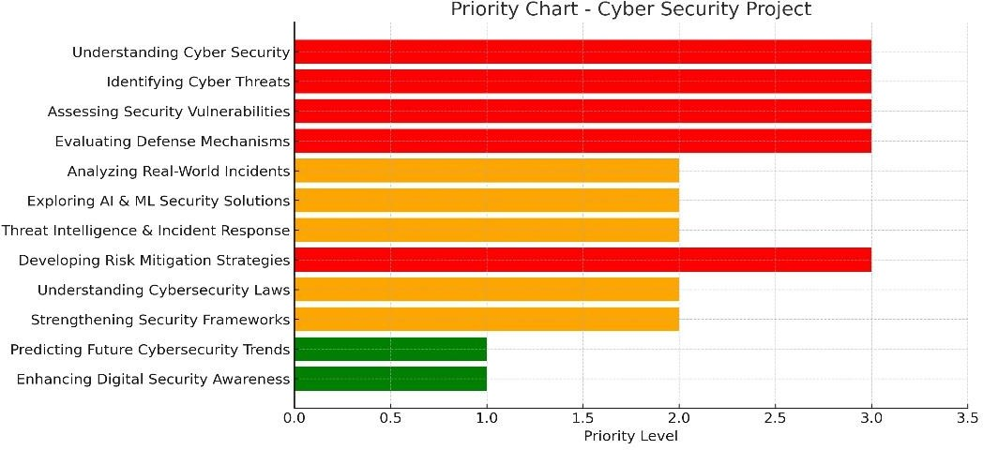

**Step 4: Empathy **